**SESS**

**I**

**ON**

**3**

**Training Guide**

**Adorama Customer Service**

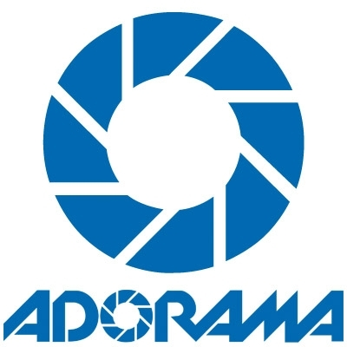

# Training Agenda

* Sent Wrong Item and Listing Error
  + Adorama
  + Amazon
  + Rakuten
  + eBay
  + Amazon.ca
  + Newegg
* Mixed Order
  + Order less than $20.00
  + Order more than $20.00
* Missing Item
  + Adorama bundle
  + Manufacturer’s bundle
  + QTCP Cold Seal
* Missing Part
  + New Item
  + Used Item

**Sent Wrong Item and Listing Error**

Listing error

-is a mistake or inaccuracy is the description of the item listed in a specific website.

Sent Wrong Item

-it is an issue in the warehouse wherein the item sent to the customer is different from what they have ordered.

**Adorama Listing Issues**

The customer ordered the item directly from Adorama but they are claiming that the item they received is different from what they have ordered.

Investigation Process

1. Check the Adorama Order history if the SKU in AS400 matches the SKU in the order history.

2. Get the SKU of the item from the order and check it on our website and review the item description, features, tech specs and listing picture.

3. Compare our listing from the MFG listing/B&H listing. If it’s different, then it is a listing issue. If the manufacturers’ listing is the same with our listing, it is possibly a wrong item sent.

Return Process

1. Provide our return instructions to the customer. (*Use Macro*)

2. Send a prepaid label

3. Email [CSFollowup@adorama.com](mailto:CSFollowup@adorama.com) to report the error. (*Use the subject line code guide*)

NOTE: You may ask photo from the customer if needed. Only when we receive the photos can we start with the investigation.

**Amazon Listing Issues**

The customer ordered the item from Amazon.com and Adorama is the seller but they are claiming that the item they received is different from what they have ordered.

Investigation Process

1. Get the ASIN of the item from the customer and check it on www.amazon.com. If the customer cannot provide you the ASIN check with Ricardo, Jen, Dexie and Karen by giving them Amazon order #.

*- You may also look for the item directly on Amazon but make sure that Adorama is the seller.*

2. Get the manufacturer’s part # and compare it from the manufacturer’s part # listed in our website.

3. Review the item description, features, tech specs and listing picture in Amazon and compare it from our listing.

4. If the Amazon listing is the same with our listing, compare it from the MFG listing/B&H listing. If the manufacturers’ listing is the same with our listing, it is possibly a wrong item sent.

Return Process

1. Provide our return instructions to the customer. (*Use Macro*)

2. Send a prepaid label

3. Email [CSFollowup@adorama.com](mailto:CSFollowup@adorama.com) to report the error. (*Use the subject line code guide*)

NOTE: You may ask photo from the customer if needed. Only when we receive the photos can we start with the investigation.

**Rakuten Listing Issues**

The customer ordered the item from Rakuten and Adorama is the seller but they are claiming that the item they received is different from what they have ordered.

Investigation Process

1. Get the Rakuten order confirmation email from the customer.

*- You may also look for the item directly on Rakuten but make sure that Adorama is the seller.*

2. Get the manufacturer’s part # and compare it from the manufacturer’s part # listed in our website.

3. Review the item description, features, tech specs and listing picture on Rakuten and compare it from our listing.

4. If the Rakuten listing is the same with our listing, compare it from the MFG listing/B&H listing. If the manufacturers’ listing is the same with our listing, it is possibly a wrong item sent.

Return Process

1. Provide our return instructions to the customer. (*Use Macro*)

2. Send a prepaid label

3. Email [CSFollowup@adorama.com](mailto:CSFollowup@adorama.com) to report the error. (*Use the subject line code guide*)

NOTE: You may ask photo from the customer if needed. Only when we receive the photos can we start with the investigation.

**eBay Listing Issues**

Transfer the call to eBay customer support.

**Amazon.ca Listing Issues**

The customer ordered the item from Amazon.ca and Adorama is the seller but they are claiming that the item they received is different from what they have ordered.

Investigation Process

1. Get the ASIN of the item from the customer and check it on www.amazon.ca.

*- You may also look for the item directly on Amazon.ca but make sure that Adorama is the seller.*

2. Get the manufacturer’s part # and compare it from the manufacturer’s part # listed in our website.

3. Review the item description, features, tech specs and listing picture in Amazon.ca and compare it from our listing.

4. If the Amazon listing is the same with our listing, compare it from the MFG listing/B&H listing. If the manufacturers’ listing is the same with our listing, it is possibly a wrong item sent.

Return Process

1. Provide our return instructions to the customer. (*Use Macro*)

2. Open an F6 notes to *Claims for the Canada Post Return Label

3. Email [CSFollowup@adorama.com](mailto:CSFollowup@adorama.com) to report the error. (*Use the subject line code guide*)

NOTE: You may ask photo from the customer if needed. Only when we receive the photos can we start with the investigation.

**Newegg Listing Issues**

The customer ordered the item from Newegg and Adorama is the seller but they are claiming that the item they received is different from what they have ordered.

Investigation Process

1. Get the Newegg order confirmation email from the customer.

*- You may also look for the item directly on Newegg but make sure that Adorama is the seller.*

2. Get the manufacturer’s part # and compare it from the manufacturer’s part # listed in our website.

3. Review the item description, features, tech specs and listing picture on Newegg and compare it from our listing.

4. If the Newegg listing is the same with our listing, compare it from the MFG listing/B&H listing. If the manufacturers’ listing is the same with our listing, it is possibly a wrong item sent.

Return Process

1. Provide our return instructions to the customer. (*Use Macro*)

2. Send a prepaid label

3. Email [CSFollowup@adorama.com](mailto:CSFollowup@adorama.com) to report the error. (*Use the subject line code guide*)

NOTE: You may ask photo from the customer if needed. Only when we receive the photos can we start with the investigation.

**Mixed Order**

If the issue is not listing error or sent wrong item, it is possibly a mixed order. Mixed order is a shipping department issue wherein orders were mixed up with one another (i.e. order A went to B and B went to A).

Before confirming to the customer that it was indeed an MO issue, verify first if the customer received an invoice showing a different name or order/invoice #.

* If the customer said yes, asked for the name or order number to pull up the record for that particular item and customer.
* If the customer said no, ask for the item received by the customer. You can ask for the MFG # or UPC Code. After that check the picking batch information of the order made by the customer. To do this, go into the order with a “7” and hit F7 to view the full batch of picking.

The highlighted order number is the order made by the customer. Look for a possible mixed up using the SKU of the item received by the customer. If there is a match, follow the mixed order process. If not, follow the return process of sent wrong item.

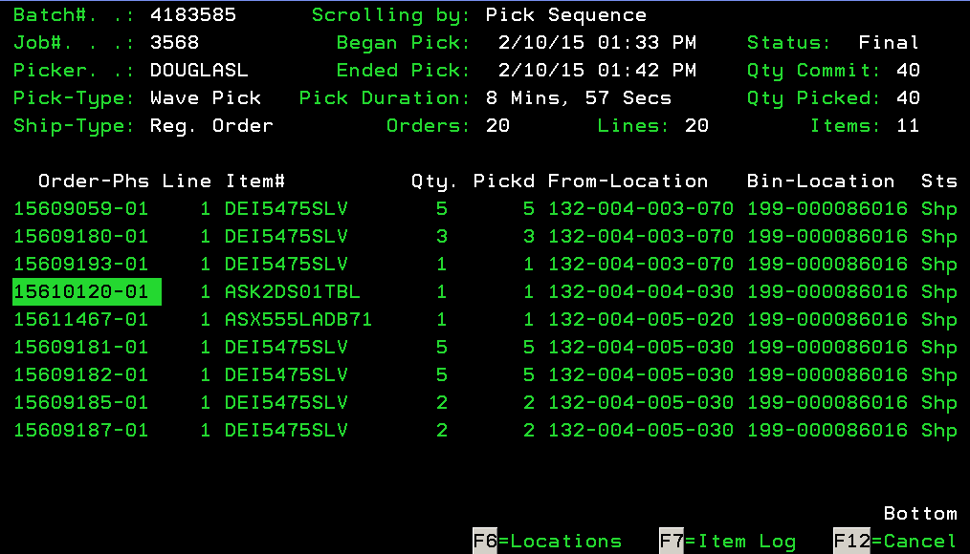

* + **$15.00 and below** – We offer refund or reship right away. No ERL is needed.
  + **$15.00 up to $100.00** – We send and ERL and we can offer refund or reshipment right away
  + **$100.00 above** – We send ERL and we can process reshipment once we see a return scan on the tracking page.
* Send an email to csfollowup@adorama.com to report the issue.
* If the order is international, follow the international defective return instruction.

**Missing Item and Missing Part**

**Missing Item**

- Is a claim that an item (SKU) is missing from the order and we show it shipped.

Ask the customer to check the box thoroughly. Check the order if it has multiple phases to confirm whether the item that is missing is there or not. If it was part of a different phase, advise the customer accordingly depending on the status of that phase.

If the missing item is not there or if the order doesn’t have multiple phases; compare the estimated weight and actual shipping weight. If the weight is off, check the inventory flow (option 10 then option 3) if there’s an adjustment.

If there is no adjustment in the warehouse and the item is more than $25.00, email [csfollowup@adorama.com](mailto:csfollowup@adorama.com) to check with the warehouse/buyer if we can send another item to the customer. If it’s just for a minimal value, open a note to your supervisor for a refund/reshipment.

If there was an adjustment, open a notes to *CREDITS if the item is more than $25.00 for reshipment or refund or your supervisor if it’s less than $25.00, email [csfollowup@adorama.com](mailto:csfollowup@adorama.com) to check with the warehouse/buyer if we can send another item to the customer.

If the weight is ok and the missing item is less than $50.00, open a note to *CLAIMS for an internal damage claim and *CREDITS for a refund/reship request.

If it’s more than $50.00, email [csfollowup@adorama.com](mailto:csfollowup@adorama.com) to check with the warehouse/buyer if we can send another item to the customer.

* **QTCP Cold Seal**

If the customer claims that the item in their order is missing and it was packed by QTCP, we can immediately offer a refund or reshipment to the customer.

Missing Part

-Is a claim that a part or accessory from an item is missing.

Check the item first if the item really comes with that specific part. If not, advise the customer that the item is not included.

If you confirmed that it is really a missing part, check if we have the same item in the repair file by going to option 10 (Item information Menu) then option 6 (Item Repair File maintenance). Enter the SKU of the item that has a defective part.

* If we have it, email [csfollowup@adorama.com](mailto:csfollowup@adorama.com) to check if we can get the missing part.
* Our FF liaison will check with the warehouse it we have the same part that can be sent to the customer.
* If we have it, FF will update the customer that we are sending them the missing part.
* If we don’t, FF liaison will check if we are selling it separately. If it’s minimal value, he/she will just send a no charge order to the customer for the broken part.
* If the part is expensive, FF liaison will contact the MFG for part replacement.
* If the MFG will be able to send it to the customer, FF liaison will inform the customer.
* If MFG cannot send it, FF liaison will offer discount to the customer.
* If the customer doesn’t want a discount, customer may return the product to us for a refund or exchange.

Send an ERL and return instruction to the customer.

* + Go into the order with an “8” and hit “CTRL”.
  + Put “Y” on the Send UPS Return Label option and hit “CTRL”.
  + Enter the actual shipping weight of the order/item and round it to the next whole number.

**Used Item Missing Part**

Used items do not include all accessories and parts as new items does, all used items are advertised with what is to be included with it. Once a used item has been purchased, it will be removed in the listing immediately therefore we cannot use the website to check the accessories included. To check for this information, you need to use AS400.

Go to option 11 (Misc Customer Service Menu) then option 3 (Work with Used Item). Enter the SKU of the used item in the USED# field and hit “CTRL”.

Select the line # and enter 5 to view the details of that used item. The screen will show like this.

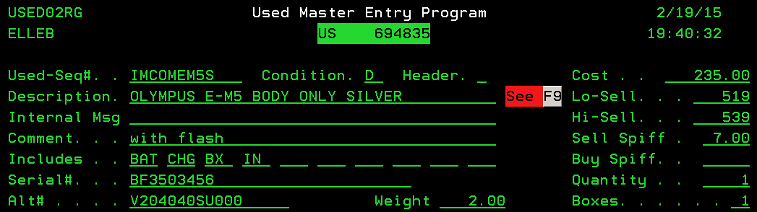

If the item that the customer is looking for is not listed in the comment and includes fields, then advise the customer that it doesn’t come with that part.

If it should come with that part, advise the customer that we will contact our used department regarding the missing part. Email [marquitak@adorama.com](mailto:marquitak@adorama.com) to report the issue.

**Other shipping department issues**

**(Poorly Packed, Item in used Condition)**

If the customer is complaining on how we packed the order or if they said that the item is in used condition, try to offer a discount depending on the value of the item. If the customer doesn’t want a discount, they may return the item to us if it’s more than $25.00 or advise them to keep it if it’s for a minimal value only.

***Additional Notes:***

**Cycle 10: Work Book**

2017